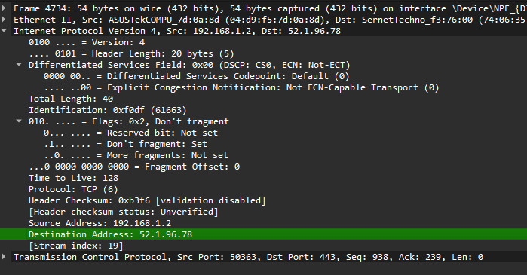

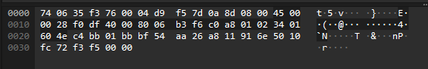

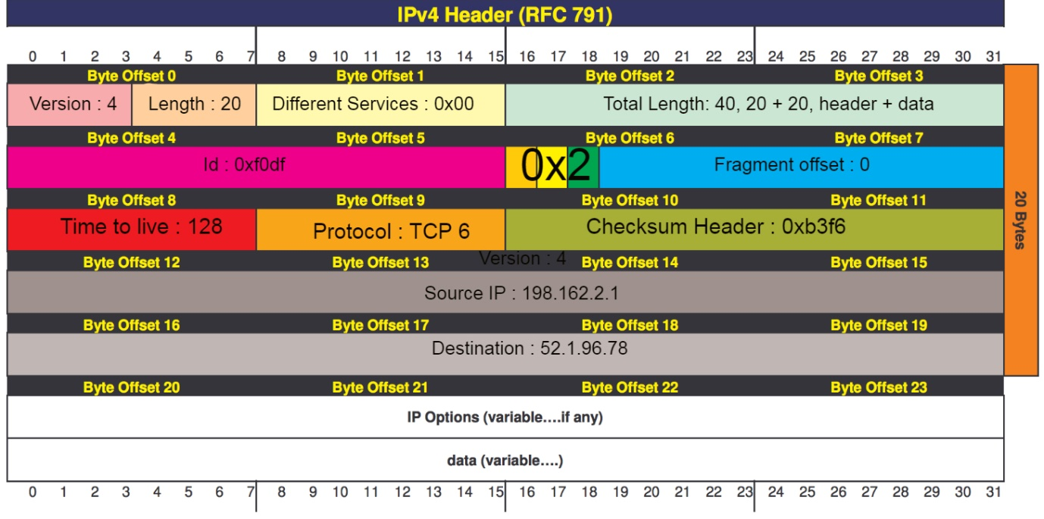

Version -> Version 4 (indicates ip version so it’s IPV4)

Length -> 20 (length of byte header no words so default is 20)

Different Services -> 0x00 (used to prioritise traffic, here nothing is being prioritised)

Total Length -> 40 (total size of packet i.e the header + the data)

Id - > 0xf0df (unique ID used to reassemble fragment packets)

Flags -> 0x2 (tells to not fragment packets, used to control fragments)

Fragment Offset -> 0 (position of fragmented data, no data is fragmented here so its 0)

Time to Live -> 128 (Max number of hops this packet can travel through)

Protocol-> TCP 6 (Specific protocol)

Header Checksum -> 0xb3f6 (for errors and validation of packets not being corrupted)

Source IP-> 192.168.1.2 (Source IP of the sender)

Destination -> 52.1.96.78 (Receiver of packet, the destination)

3 games and technical/ design highlights:

TFT(Team fight Tactics) -> leading game in auto chess genre, I like the interactivity and automatic awareness of the AI chess pieces that fight each other. Each unit is able work independently and all you have to do is watch them fight since they have a smart AI.

Dragon Quest 9 -> Feature I like in this is the turn based combat and smoothness of how it works. It takes into account player stats and luck chances and enemy stats and makes the enemy ai work based on what class it is facing and I like how turn based combat works as a feature and game design aspect. Makes you think more of how to act.

Terraria -> Feature I like is how the world is generated new every time you create a world and how there are events that happen in each world but it takes your world layout into concern when deciding how to impact the world. The worlds are different but the same everytime so it almost gives a new experience every time you play the game.

Applications/Services:

Discord

Spotify

Gmail

X

Github

ChatGPT

uTorrent

Pixlr

Fl studio

SurfShark VPN